# https://tse4.mm.bing.net/th?id=OIP.O6unPbbMKIeEnUkEpJgq_QDeDI&pid=15.1&P=0&w=203&h=184http://aavpc.ac.in/Common/Uploads/MenuTemplate/5_Menu_Untitled.pngShri Vile Parle KelvaniMandal’s

**DWARKADAS J. SANGHVI COLLEGE OF ENGINEERING**

(Approved by AICTE and Affiliated to the University of Mumbai)

**IETE-SF**

**of**

**Electronics & Telecommunication Department**

**Presents**

**DJ STRIKE 2018-19**

Project Proposal Work On

**Density Based Traffic Signal**

**Group ID: 134**

**Group Members**

**Name SAP ID Department Year**

**1.AjinkeyaChitrey 60002160010 EXTC TE**

**2.VirenBaria 60002160005 EXTC TE**

**3.Dhanam Parekh 60002170030 EXTC SE**

**4.DhruvKadakia 60002170032 EXTC SE**

**BE Mentor:-JeneelKachhadiya**

**Faculty Guide:- Prof. YuktiBandi**

**PROJECT OBJECTIVE / ABSTRACT**

Due to the increase in the number of vehicles day by day, traffic congestions and traffic jams are very common. One method to overcome the traffic problem is to develop an intelligent traffic control system which is based on the measurement of traffic density on the road using real time video and image processing techniques. The theme is to control the traffic by determining the traffic density on each side of the road and control the traffic signal intelligently by using the density information. This paper presents the algorithm to determine the number of vehicles on the road. The density counting algorithm works by comparing the real time frame of live video by the reference image and by searching vehicles only in the region of interest (i.e. road area). The computed vehicle density can be compared with other direction of the traffic in order to control the traffic signal smartly.

In this method, a webcam is used in each stage of the traffic light in order to take pictures of the roads where traffic is bound to occur. Count of vehicles in these images is calculated using image processing tools in Matlab and different timings are allocated according to the count along with a green signal for vehicles to pass. In the proposed prototype, the green and red signals are represented using LEDs and the decrementing timer for the green signal is represented by a seven segment display.

**KEYWORDS**

Traffic density count, image processing, intelligent controlling of traffic,foregrounddetection, vehicle count, timer.

**MOTIVATION / SCOPE OF THE PROJECT**

Inefficient management of traffic causes wastage of invaluable time, pollution,wastage of fuel, cost of transportation and stress to drivers,etc. but more importantly emergency vehicles like ambulance get stuck in traffic. Our research is on density based traffic control with priority to emergency vehicles like ambulance and fire brigade. So, it is very much necessary to design a system to avoid the above casualtiesthus preventing accidents, collisions, and traffic jams. The common reason for traffic congestion is due to poor traffic prioritization, where there are situations some lanehave less traffic than the other and the equal green signal duration for both affect the wastage of resources and drivers are stressed.

Controlling traffic signals using timers and electrical sensors is known as automatic controlling. In this method, a constant numerical value is uploaded into the timer at each phase of the traffic light. According to the changes in the timer value, the traffic lights automatically becomes ON or OFF. The electrical sensors check for the presence of vehicles on the road and provide appropriate signals at each phase, which controls the automatic switching off lights. The manual controlling system requires tremendous manpower for implementation.

In the future this project will have real industry applications too as the image processing and density count mechanisms can help the city pre-plan the traffic management methodologies by studying the traffic statistics on particular routes and how this system can further be integrated with Artificial Intelligence systems so that the signals ahead can plan their signaling response based on traffic at the previous signal junctions for smoother traffic flow. Also help reduce manual labor especially in countries like India and also help the health-care vehicles like ambulances or even fire brigade vehicles to respond in time to casualties irrespective of the road traffic conditions.

**METHODOLOGY:**

The algorithm consists of the following steps:

1. We have a reference image and the image to be matched is continuously captured using a camera that is installed at the junction.
2. The images are pre-processed in two steps:

* Images are relocated to 300x300 pixels.
* Then the above rescaled images are converted from RGB to gray.

1. Edge detection of pre-processed images is carried out using Canny edge detection technique.
2. The output images of previous step are matched using pixel to pixel matching technique.
3. After matching the timing allocation is done depending on the percentage of matching as:

* If matching is between 0 to 30% - green light is on for 90 seconds.
* If matching is between 30 to 50% - green light is on for 60 seconds.
* If matching is between 50 to 70% - green light is on for 30 seconds.
* If matching is between 70 to 90% - green light is on for 20 seconds.
* If matching is between 90 to 100% - red light is on for 90 seconds.

**DESCRIPTION OF THE PROJECT:**

* Hardware Module:

A USB based web camera to capture images of the traffic on road. The hardware module consists of an Arduino board used to control LEDs representing the red and green lights. A timer module is used to display the remaining time.

* Software Module:

MATLAB version R2016a is used as the image processing software which comprises specialized modules that perform specific tasks. Matlab coding is completed using the reference and captured images.

* Image Acquisition:

A 2-D image is captured using camera module of Arduino Uno which live captures the image of road and vehicles in front of it and f(x,y) is amplitude of image or gray level at coordinate (x,y) of image. f(x,y) is positive finite valued.

* Image Resizing:

Images are resized so as to make resolution compatible for all camera specifications.

* RGB to GRAY Conversion:

Humans perceive color images in RGB format. To convert this RGB image to grayscale we have to consider RGB value of each pixel and make output as a single value reflecting brightness of that pixel. The grayscale pixel values are expressed as : Grayscale pixel= 0.3R + 0.59G + 0.11B

* Image Enhancement:

Image Enhancement is done to adjust digital images so that results are more suitable for display and analysis for example reducing noise in the image to make it easier to identify key characteristics. In poor contrast images the adjacent characters merge during binarization. To reduce spread of characters we use POWER LAW TRANSFORMATION to increase contrast between characters. The basic law is: s=cry where r and s are input and output intensities respectively c and y are positive constants. In our project we fix c=1 and vary y(gamma) between 1&5 so that there is no spread in image after binarization.

* Edge Detection:

Edge Detection refers to mathematical methods which aim to identify points in a digital image at which image brightness changes sharply or more technically has discontinuities or noise. The points at which image brightness alters sharply are organized into s set of curved line segments termed edges. We will use CANNY EDGE DETECTION method due to its low error rate well localized edge points and single edge point response. The algorithm works as follow:

* Smooth the input image with Gaussian filter.
* Compute the gradient magnitude and angle images.
* Apply non-maxima suppression to gradient magnitude image.
* Use double thresholding and connectivity analysis to detect and link edges.
* Image Matching:

We use a reference image and match it pixel by pixel with the real time image captured. Reference image is stored in matrix form in memory and real time image is also converted to desired matrix. For images to be same their pixel values in matrix must be same which is called pixel matching. If there is any mismatch in pixel value it adds on to the counter and used to calculate number of pixel mismatches which is expressed as:

%match=(No. of pixels matched successfully) **/**(Total no. of pixels)

* Timing Allocation:

The timing allocation is done depending upon percentage match:

1. If matching is between 0 to 30% - green light on for 90 seconds
2. If matching is between 30 to 50% - green light on for 60 seconds
3. If matching is between 50 to 70% - green light on for 30 seconds
4. If matching is between 70 to 90% - green light on for 20 seconds
5. If matching is between 90 to 100% - red light on for 90 seconds

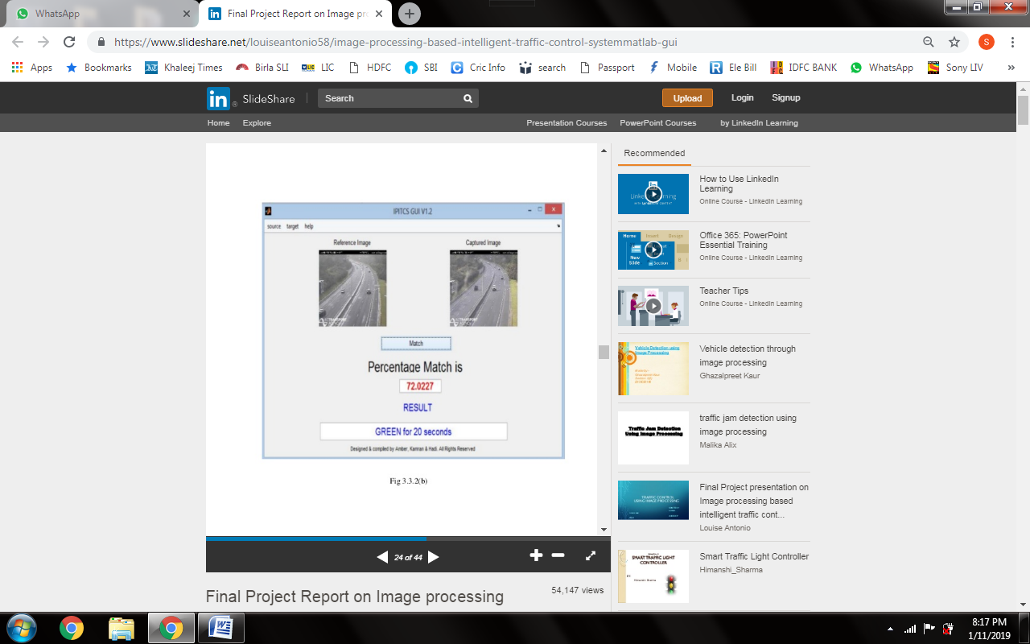

**Fig 1. Captured and reference image comparison**

**SCHEMATIC / BLOCK DIAGRAM**

**Input Frame**

**Camera Module**

**Image Processing System**

**Captured Data**

**Arduino UNO**

**4-way LED’s system**

**Timer Allocation**

**Fig 2. Basic Block Diagram of System**

**Captured Image**

**Reference Image**

**RGB to Gray Conversion**

**RGB to Gray Conversion**

**Image Resizing**

**Image Resizing**

**Image enhancement**

**Image enhancement**

**Edge Detection**

**Edge Detection**

**Image Matching**

**Timing Allocation**

**Fig 3. Image Processing System**

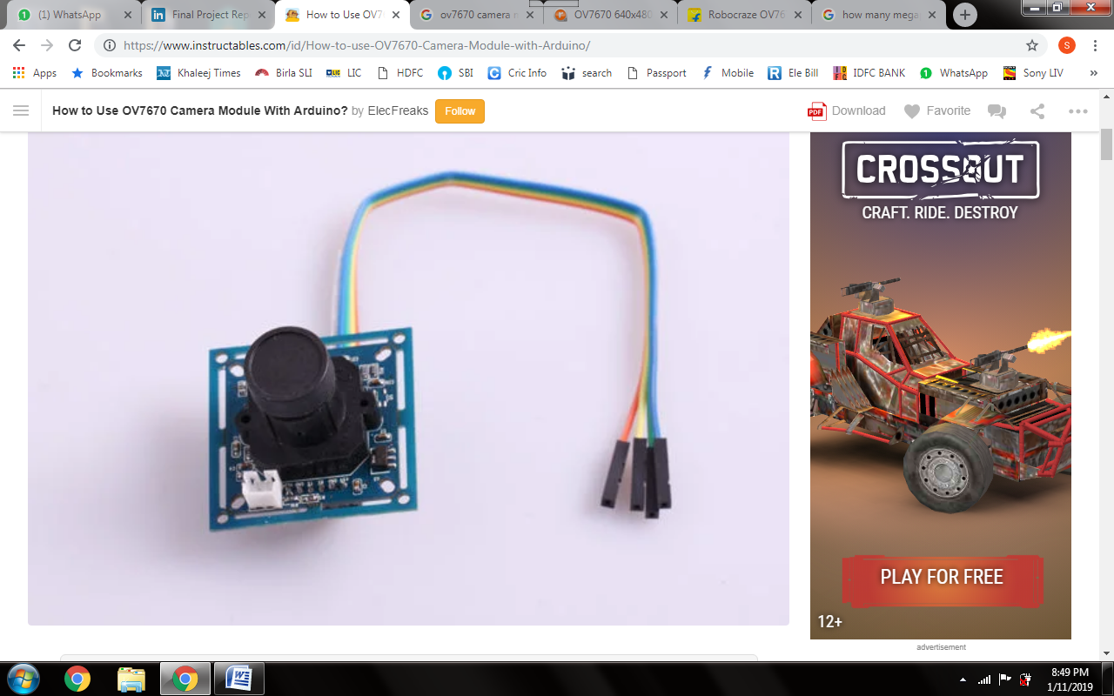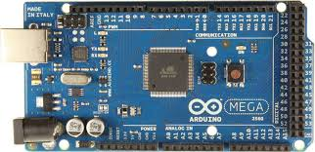

**Fig 4. OV7670 Camera Module Fig 5. Arduino MEGA**

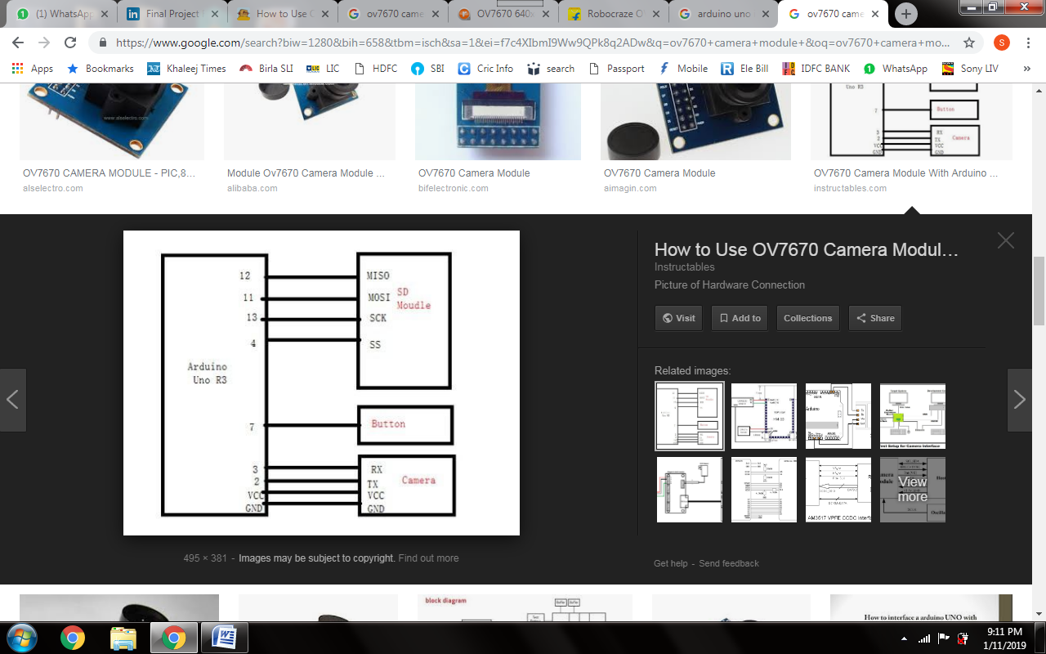

**Fig 4. Interfacing camera module with Arduino Uno**

**WORK PLAN / TIMELINE CHART / GANTT CHART**

|  |  |  |
| --- | --- | --- |
| Weeks | Work | Outcome |
| Week 1 & Week 2 | Collecting raw data and documentation.  Testing Sample code. | Work plan will be prepared. |
| Week 3 | Getting components &other required materials.  Testing camera module with Arduino. | Find overview & components will be decided. |
| Week 4 & Week 5 | Developing the final image processing algorithm. | Image processing is developed & tested against interference images |
| Week 6 & Week7 | Interfacing the image processing algorithm with developed hardware. | Hardware & software components are working in sync. |
| Week 8 | Basic testing. | Sample results. |
| Week 9 & Week 10 | Further development in image processing (priority vehicles) & using object segmentation. | Extension will be added and project will be completed. |

**BUDGET**

|  |  |  |
| --- | --- | --- |
| Components |  | Cost (in Rs.) |
| Arduino MEGA |  | **800.00** |
| Camera Module |  | **600.00** |
| 12 (4×3) RYG LEDs |  | **45.00** |
| 12 (4×3) 330/220 ohms resistors |  | **30.00** |
| Breadboard |  | **100.00** |
| Jumper Cables×2 |  | **200.00** |
| Batteries (9V) |  | **60.00** |
| Miscellaneous |  | **1000.00** |
| TOTAL |  | **2835.00** |

**REFERENCES**

* Smart Control of Traffic Signal System using Image Processing by V. Parthasarathi, M. Surya, B. Akshay, K.Murali Silva and Shriram K. Vaudevan
* Traffic Density Measurement using Image Processing: An SVM approach by International Journal of Innovative Research in computer and Communication Engineering
* <https://www.slideshare.net/louiseantonio58/image-processing-based-intelligent-traffic-control-systemmatlab-gui>
* [www.irjet.net](http://www.irjet.net)
* [www.researchgate.net](http://www.researchgate.net)